Dynamic Calendar Automation

Project Overview
MakeMyTrip is a leading travel booking platform that provides flight, hotel, and holiday package booking services. One of the most critical and dynamic components of the platform is the date selection calendar, which changes based on user interaction, availability, pricing, and month navigation.
The objective of this project is to automate the dynamic calendar functionality on the MakeMyTrip website using Tricentis Tosca, ensuring reliable and flexible date selection for flight booking scenarios without relying on hard-coded values.

Problem Statement
The calendar on the MakeMyTrip website is highly dynamic. Calendar dates vary based on:
- Current system date
- Seat or fare availability
- Navigation between months
Because of this dynamic behavior, static date selection methods are unreliable and may cause test failures.
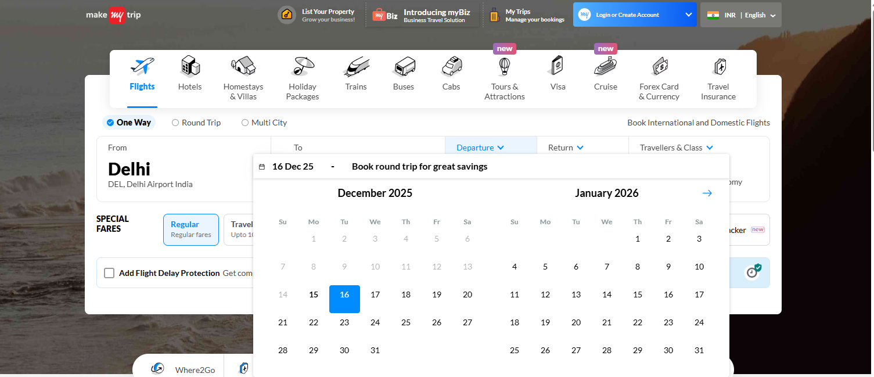

Automation Objective
The automation solution should:
- Dynamically identify calendar elements using stable and unique properties
- Select only available dates
- Ensure the selected date is greater than today’s date
- Avoid hard-coded date values
- Work consistently across different months and calendar states

Tosca Module Design Approach
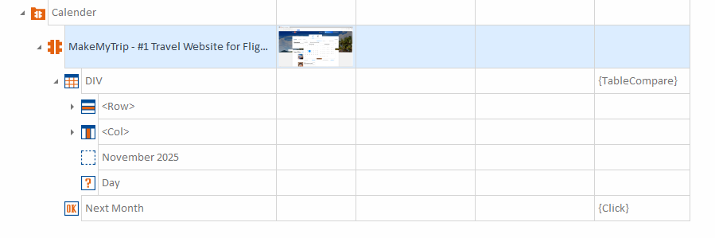
To ensure stability in automation:
- Create a robust Tosca module for the calendar
- Identify each UI object using a combination of identification properties (such as attributes, text patterns, and hierarchy)
- Ensure the module works even when the calendar UI changes dynamically

Business Rule
- Select a departure date dynamically only if:
  - The date is available
  - The date is greater than today’s date
- Store the selected date in a Buffer
- Proceed with the test execution only if the condition is satisfied

Test Scenario
Scenario: Dynamic Date Selection for Flight Booking
- The user wants to travel on a specific future date (stored in a Tosca Buffer).
- The automation script checks whether the required date is visible in the current calendar month.
- If the date is not visible:
  - Click on Next Month
  - Re-check the calendar
  - Repeat this step until the required month and date are displayed
- Once the required date appears:
  - Verify the date is available
  - Click on the required date
- Store the selected date in the Buffer and continue with the booking flow
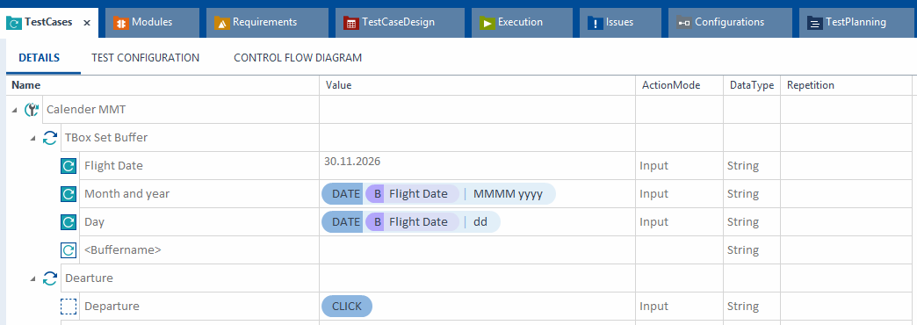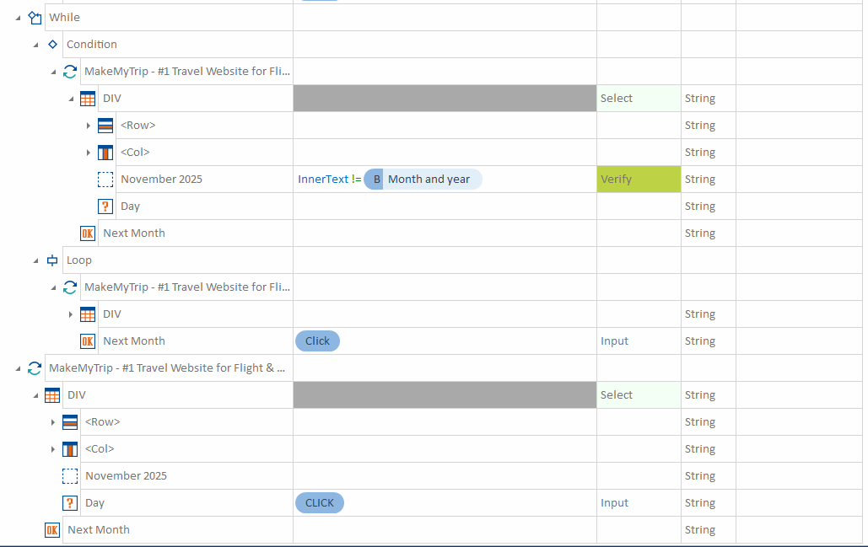

Expected Outcome
- Reliable and reusable calendar automation
- No dependency on static or hard-coded dates
- Stable execution even with dynamic UI changes
- Improved maintainability and scalability of test cases
I’ve rewritten your content into a clear, well-structured, and professional document in the canvas.
If you want, I can:
- Simplify it further (very basic / beginner-friendly)
- Convert it into test case format
- Align it with Tosca best practices
- Rewrite it for interview or documentation submission
- Export it as step-by-step automation logic

